Assignment 5

7.7. Suppose that we will take a random sample of size n from a population having mean  and standard deviation . For each of the following situations, find the mean, variance, and standard deviation of the sampling distribution of the sample mean :
a 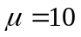,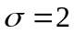, n=25
b 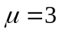,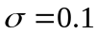, n=4
c 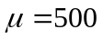,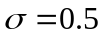, n=100
Solution: a.
b.
c.
7.11. THE BANK CUSTOMER WAITING TIME CASE
Recall that the bank manager wants to show that the new system reduces typical customer waiting times to less than 6 minutes. One way to do this is to demonstrate that mean of the population of all customer waiting times is less than 6. Letting this mean be, in this exercise we wish to investigate whether the sample of 100 waiting times provides evidence to support the claim that is less than 6.
For the sake of argument, we will begin by assuming that equals 6, and we will then attempt to use the sample to contradict this assumption in favour of the conclusion that is less than 6. Recall that the mean of the sample of 100 waiting times is =5.46 and assume that, the standard deviation of the population of all customer waiting times, is known to be 2.47.
- Consider the population of all possible sample means obtained from random samples of 100 waiting times. What is the shape of this population of sample means? That is, what is the shape of the sampling distribution of ? Why is this true?
- Find the mean and standard deviation of the population of all possible sample means when we assume that equals 6.
- The sample mean that we have actually observed is =5.46. Assuming that equals 6, find the probability of observing a sample mean that is less than or equal to =5.46.
- If equals 6 , what percentage of all possible sample means are less than or equal to 5.46? Since we have actually observed a sample mean of =5.46, is it more reasonable to believe that (1) equals 6 and we have observed one of the sample means that is less than or equal to 5.46 when equals 6, or (2) that we have observed a sample mean less than or equal to 5.46 because is less than 6? Explain. What do you conclude about whether the new system has reduced the typical customer waiting time to less than six minutes?
Solution: a. Normal because the sample is large (n ≥ 30)
b.
c.
d. 1.43%; conclude that is less than 6.

7.18. In each of the following cases, determine whether the sample size n is large enough to say that the sampling distribution of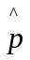 is a normal distribution.
a p=0.4, n=100 b p=0.1, n=10 c p=0.1, n=50
d p=0.8, n=400 e p=0.98, n=1,000 f p=0.99, n=400
Solution: a. np = (100)(.4) = 40 : n(1–p) = (100)(.6) = 60: Yes, sample is large enough
b. np = (10)(.1) = 1 : n(1–p) = (10)(.9) = 9: No, sample is not large enough
c. np = (50)(.1) = 5 : n(1–p) = (50)(.9) = 45: Yes, sample is large enough
d. np = (400)(.8) = 320 : n(1–p) = (400)(.2) = 80: Yes, sample is large enough
e. np = (1000)(.98) = 980 : n(1–p) = (1000)(.02) = 20: Yes, sample is large enough
f. np = (400)(.99) = 396 : n(1–p) = (400)(.01) = 4: No, sample is not large enough

7.22. In the July 29,2001, issue of The Journal News (Hamilton, Ohio)Lynn Elber of the Associated Press reported on a study conducted by the Kaiser Family regarding parents’ use of television set V-chips for controlling their children’ TV viewing. The study asked parents who own TVs equipped with V-chips whether they use the devices to block programs with objectionable content.
- Suppose that we wish to use the study results to justify the claim that fewer than 20 percent of parents who own TV sets with V-chips use the devices. The study actually found that 17 percent of the parents polled used their V-chips. If the poll surveyed 1,000 parents, and if for the sake of argument we assume that 20 percent of parents who own V-chips actually use the devices (that is, p=0.2), calculate the probability of observing a sample proportion of 0.17 or less. That is, calculate 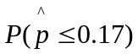.
- Based on the probability you computed in part a, would you conclude that fewer than 20 percent of parents who own TV sets equipped with V-chips actually use the devices? Explain.
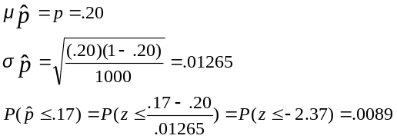Solution: a.

b. Yes, the probability of observing this sample is very small if p = .20. The true p is likely less than .20.

7.40. On January 7,2000, the Gallup Organization released the results of a poll comparing lifestyles of today with those of yesteryear. The poll results were based on telephone interviews with a randomly selected national sample of 1,031 adults, 18 years and older, conducted December 20-21,1999. One question asked if the respondent had vacationed for six days or longer within the last 12 months.
a Suppose that we will attempt to use the polls results to justify the claim that more than 40 percent of U.S. adults have vacationed for six days or longer within the last 12 months. The poll actually found that 42 percent of the respondents had done so. If, for the sake of argument, we assume that 40 percent of U.S. adults have vacationed for six days or longer within the last 12 months( that is, p=0.4), calculate the probability of observing a sample proportion of 0.42 or more; that is, calculate 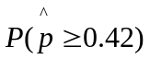.
b Based on the probability you computed in a, would you conclude that more than 40 percent of U.S. adults have vacationed for six days or longer within the last 12 months? Explain.
Solution: a.
b. Perhaps, but the evidence is not terribly strong.

